**Primary Magpie Curriculum Overview**

Our curriculum at The Magpie Learning Centre for our Primary students is based around our core aims.

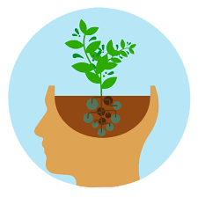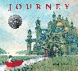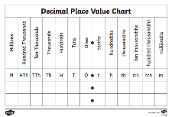During your child’s time with us, they will be learning about the following things:

**COMPUTING**

At the Magpie, computing is embedded throughout all subjects. Pupils will have the opportunity to use search technologies and use simple algorithms.

We believe that online safety is essential in ensuring pupils are safe in the digital

world.

**PSHE**

Our two units are titled Be Yourself and Think Positive.

Alongside the Core Aims, pupils will find out more about themselves and learn strategies to develop a positive view of themselves. Through games and practical activities, pupils will experience making good choices and apply a growth mindset approach

to life.

**SCIENCE**

As one of the core subjects, students who attend the Magpie will have experience of working scientifically through taking part in engaging and practical opportunities.

Our activities are used to teach real and scientific principles through a fun and hands-on way. Pupils will:

* Plan different types of scientific enquiries to answer questions.
* Take measurements using a range of scientific equipment.
* Record data and results using scientific diagrams, labels tables and graphs.
* Use test results to make predictions.
* Present their findings, including conclusions.

**ART**

Our art experiences at the Magpie focus on helping to develop self-confidence, self-discipline and resilience. Our art lessons provide children with opportunities to develop their skills using a range of media and materials

including drawing, painting and

sculpture.

**MATHS**

In maths we will be focusing on Place Value including:

* Reading, writing and comparing numbers.
* Counting forwards and backwards in steps of powers of 10.
* Rounding numbers.
* Solving number problems.

In our Addition and Subtraction unit we will:

* Add and subtract whole numbers mentally and using a written calculation.
* Solve addition and subtraction problems.
* Identify multiples and factors.

**ENGLISH**

Our English lessons will be based around the book Journey by Aaron Becker and Can I Build Another Me? By Shinsuke Yoshitake. Pupils will develop their skills in the following areas:

* Predicting what might happen in texts through what is stated and applied.
* Making comparisons within and across books.
* Using dictionaries to check the spelling and meaning of words.
* Consider how authors have developed characters and settings.
* Describe settings, characters and atmosphere.
* Assess the effectiveness of their own and others writing.

**PE**

Physical Education is a great way to improve health, reduce stress and develop concentration.

Pupils will take part in a range of key skills including running, jumping, throwing and catching.

**GARDENING AND FOREST SCHOOL**

Gardening and Forest School at the Magpie is a unique way of encouraging our pupils to independently explore the natural environment. Pupils will have the opportunity to focus on the Core Aims including solving problems and co-operating with others.

**CORE AIMS:**

* Social Skills
* Self-control
* Self-awareness
* Self-worth
* Resilience
* Independence
* Ambition