Curriculum Intent
At The Magpie Learning Centre, we engage with the whole school community to create a happy, safe and nurturing environment where our students are motivated to learn. Our highly trained staff use a variety of teaching and learning strategies to motivate, engage and inspire each individual learner, so that every child in our care achieves their full potential. Our classrooms are bright and engaging spaces where pupils are all valued, want to learn and feel proud of their successes.

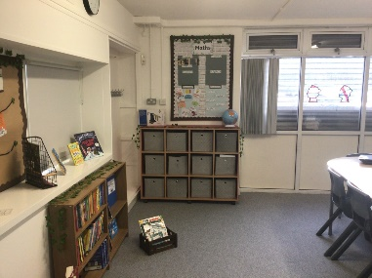
As our primary students are with us for a short period of 6-8 weeks attending twice weekly, we ensure that our curriculum offer is flexible, personalised and tailored to meet the individual needs of all our students. Alongside the National Curriculum objectives, there is a strong focus on personal and social development. Our overall aim is to inspire our pupils to enjoy learning and re-engage in order to continue their learning journey back in their home school.

We aim to provide meaningful learning opportunities in which pupils can develop:
- social skills
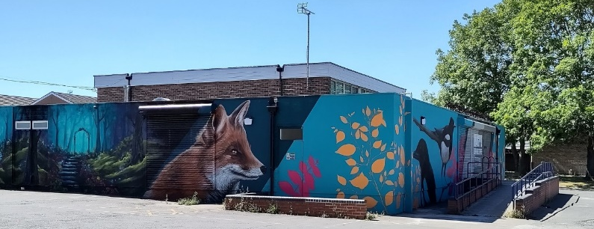
- self-control
- self-awareness
- self-worth
- resilience
- independence
- ambition

Our curriculum at the Magpie is designed to:

- Engage, motivate and inspire pupils through well-planned and engaging learning opportunities.
- Help pupils to progress from their individual starting points in the academic subjects of English, Maths, Science, Computing and PSHE.
- Improve the overall wellbeing and mental health of pupils through a variety of creative subjects and outdoor learning opportunities.
- Give our pupils the necessary skills, knowledge and understanding to progress and achieve academically, socially and emotionally when they re-integrate to their home school.

Implementation
In our Primary group we cater for students from a range of Primary Schools across both the city and county, who have encountered very different curricula during their time at school. The majority of our students have also experienced a reduced timetable and many of them are not working at age related expectations. It is therefore essential that the curriculum we offer is flexible enough to foster such a wide variety of needs.

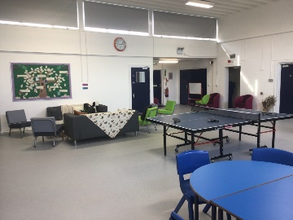
Excellent communication with the children’s home school and parents/carers is extremely important to help our students progress academically and socially within a short time frame. The detailed referral form asks for specific academic information alongside a comprehensive telephone call and regular emails to the home school. Our curriculum allows students to move at their own pace, whatever their starting point, to support and promote their individual learning and progress.

Curriculum Content
- English
- Maths
- Science
- PSHE
- Computing
- Art
- Gardening and Forest School
- Cooking

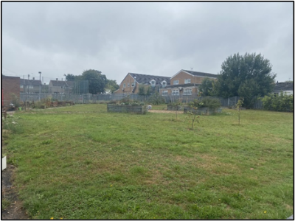
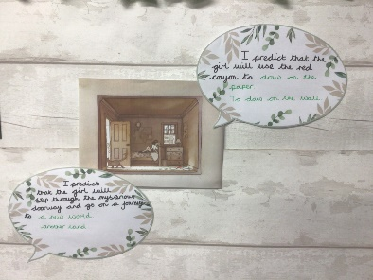
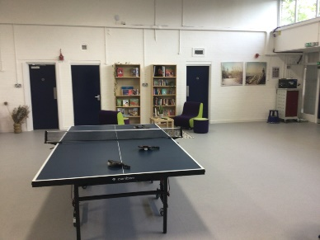

Impact
The impact of the curriculum will be measured and evaluated by student achievement and engagement.
Aim | Impact Measurement
To engage, motivate and inspire pupils through well-planned and engaging learning opportunities. | Observations of learning  Pupil voice  Attendance  Engagement scales
To help pupils to progress from their individual starting points in the academic subjects of English, Maths, Science, Computing and PSHE. | Analysis of pupil tracking sheets  Book scrutiny  Observation of learning
To improve the overall wellbeing and mental health through creative subjects and outdoor learning. | Observation of learning  Engagement scores  Analysis of engagement scores
Give our pupils the necessary skills, knowledge and understanding to progress and achieve academically, socially and emotionally at their home school. | Meeting with Primary home schools  Number of students successfully reintegrated to their home school

